Fall 2012: Masterworks of Western Literature
Modern European Drama: from Ibsen to Genet
Course number 195:203:02 – Index 13480
Tuesday and Friday, 12:35 PM – 1:55PM at Waller Hall, room 203, Cook/Douglass
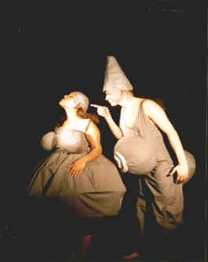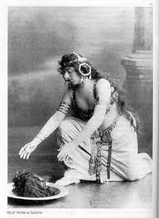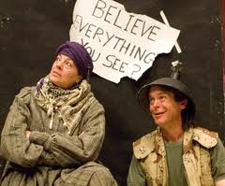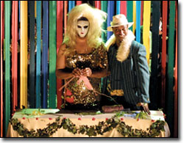

Instructor: Ben De Witte (Program in Comparative Literature)
Contact: bdewitte@eden.rutgers.edu

Course description:
In this course we will read some classics of modern dramatic literature produced in Europe in the period 1880-1950. We will consider what questions “modern” drama poses to itself and its audience. The approach in class will combine close reading and textual analysis of each play with an effort at contextualizing the works in a historical framework.
We will investigate the theater as a mode of representation that both reflects and negotiates its cultural conditions. We will examine major trends and developments of modern drama, starting with three classics of the “realist” theater by Henrik Ibsen (Norway), August Strindberg (Sweden), and Anton Chekhov (Russia). We will then turn to some of the most striking ideological and aesthetic departures from this model of theater, ranging from the “symbolist,” “aestheticist” and “proto-surrealist” work of Maurice Maeterlinck (Belgium), Alfred Jarry (France) and Oscar Wilde (Ireland), and the “proto-expressionist” work of Frank Wedekind (Germany), over the provocative works and theories of Bertold Brecht (Germany) and Antonin Artaud (France) to end by analyzing landmark plays by Federico Garcia Lorca (Spain), the “existentialist” Jean Paul Sartre (France) and the “absurdist” Samuel Beckett (Ireland) and Jean Genet (France). These various “-isms,” while not always helpful to clarify matters, do matter – as we will see – in our discussion of “modern drama” as a genre that is constantly involved in a quest for representing modern life in ever new ways.

Requirements:

*Three short papers (2-3 pages) addressing issues in a single work, or comparing two works
*A final comparative paper addressing two works (5-7 pages)
*Group presentation
*Class attendance and participation

